|  |  |  |
| --- | --- | --- |
| **Name :Mohammed Noman** | **Sub** | **: Sem-II** |
| **Roll No : 270** | **Practical** | **: 06** |

**Aim: Develop and demonstrate a HTML file that includes JavaScript for the following problems:**

1. **Input: A starting and ending number**
2. **Output: find all the prime numbers between starting and ending number.**

**Code:**

<!DOCTYPE html>

<html lang="en">

<head>

<meta charset="UTF-8">

<title>Prime Numbers Finder</title>

<style>

body {

font-family: Arial, sans-serif; margin: 40px;

background-color: #eef2f3;

}

.container {

background-color: #fff; padding: 30px;

border-radius: 10px; max-width: 500px; margin: auto;

box-shadow: 0 0 10px rgba(0,0,0,0.1);

}

h2 {

text-align: center; margin-bottom: 20px;

}

.input-group {

margin-bottom: 20px;

}

label {

display: block; margin-bottom: 8px; font-weight: bold;

}

input[type="number"] {

</head>

<body>

<div class="container">

<h2>Find Prime Numbers</h2>

width: 100%; padding: 10px; border-radius: 5px;

border: 1px solid #ccc;

}

button { width: 100%;

padding: 10px;

background-color: #007bff; color: white;

border: none; border-radius: 5px; margin-top: 10px; font-size: 16px; cursor: pointer;

}

button:hover {

background-color: #0056b3;

}

.result {

margin-top: 20px; font-size: 18px; text-align: center; color: #333;

word-wrap: break-word;

}

</style>

<div class="input-group">

<label for="startNumber">Enter Starting Number:</label>

<input type="number" id="startNumber">

</div>

<div class="input-group">

<label for="endNumber">Enter Ending Number:</label>

<input type="number" id="endNumber">

</div>

<button onclick="findPrimes()">Find Primes</button>

<div class="result" id="output"></div>

</div>

<script>

// Function to check if a number is prime function isPrime(n) {

if (n <= 1) return false; if (n === 2) return true;

if (n % 2 === 0) return false;

for (let i = 3; i <= Math.sqrt(n); i += 2) { if (n % i === 0) return false;

}

return true;

}

// Function to find prime numbers between two numbers function findPrimes() {

let start = parseInt(document.getElementById('startNumber').value); let end = parseInt(document.getElementById('endNumber').value); let primes = [];

if (isNaN(start) || isNaN(end)) {

document.getElementById('output').innerText = "Please enter valid numbers!"; return;

}

if (start > end) {

document.getElementById('output').innerText = "Starting number must be less than or equal to ending number!";

return;

}

for (let i = start; i <= end; i++) { if (isPrime(i)) { primes.push(i);

}

}

if (primes.length > 0) {

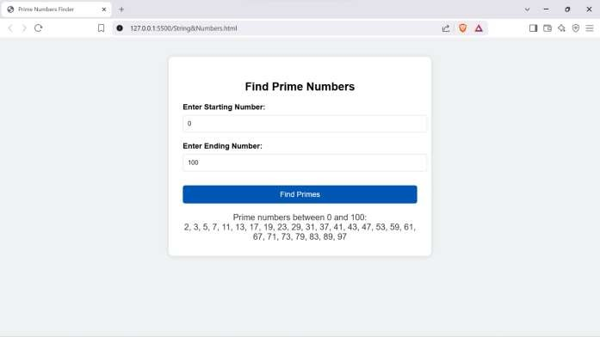document.getElementById('output').innerText = `Prime numbers between ${start} and

${end}:\n${primes.join(", ")}`;

} else {

document.getElementById('output').innerText = `No prime numbers found between ${start} and ${end}.`;

}

}

</script>

</body>

</html>

**OUTPUT:**

